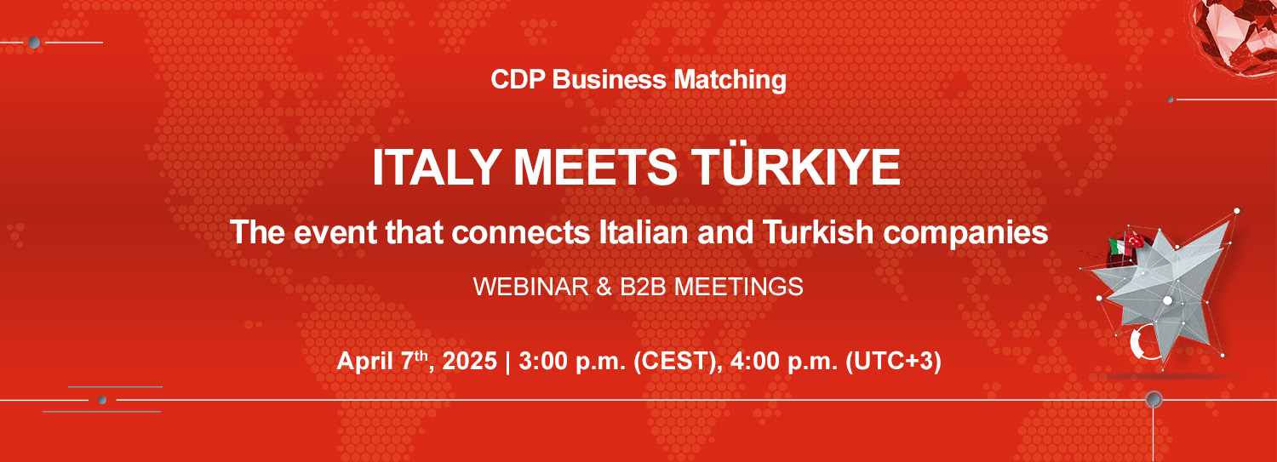

Introduced and moderated by **Laurent Franciosi**, Head of International Markets Development, CDP

|  |  |  |
| --- | --- | --- |
| **4:00 p.m. – 4:15 p.m.** | **Opening Remarks**   * **Giorgio Marrapodi**, Ambassador of Italy in Ankara * **Pasquale Salzano**, Director of European and International Affairs, CDP and President, SIMEST |  |
| **4:15 p.m. – 4:55 p.m.** | **Italy-Turkey trade relations: economic synergies and business opportunities in the main sectors of interchange**   * **Marco Pintus,** Director ITA – Italian Trade Agency in Türkiye * **Stefano Kaslowski,** President, Italian Chamber of Commerce and Industry in Türkiye - CCIIST * **Enrico Corsini,** Vice President Italian Chamber of Commerce and Industry in Türkiye - Izmir * **Lale Cander**, Türkiye-Italy Business Council Chairperson – DEIK * **Azmi Gümüşlüoğlu**, TÜSİAD Italy Working Group President & TÜSİAD Board Alternative Member responsible for EU and Transatlantic relations * Representative, Union of Chambers and Commodity Exchanges of Türkiye - TOBB |  |
| **4:55 p.m. – 5:00 p.m.** | **CDP Business matching: an innovative tool to develop new economic and trade relations between Italian and Turkish companies**   * **Riccardo Honorati Bianchi**, Head of Country System Initiatives and Business Matching Platform Coordinator, CDP |  |
| **5:00 p.m. – 5:20 p.m.** | **Financial instruments to support sustainable development and investment in Turkey and bilateral trade relations**   * **Martina Madeo**, Senior Officer Business Partnerships, CDP Development Cooperation * Representative, TSKB Industrial Development Bank of Türkiye * Representative, TKYB Development and Investment Bank of Türkiye * **Federica Ingrosso**, Senior external relations, SIMEST |  |

**5:20 p.m**  **Event Conclusion**